**Twitter mood predicts the stock market**

by Johan Bollen

Twitter Can Predict the Stock Market movement.

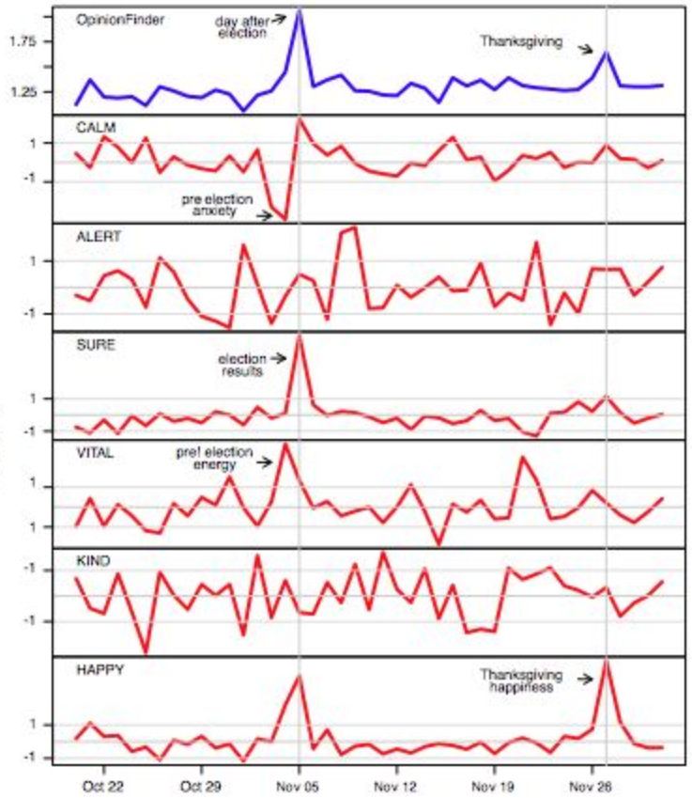

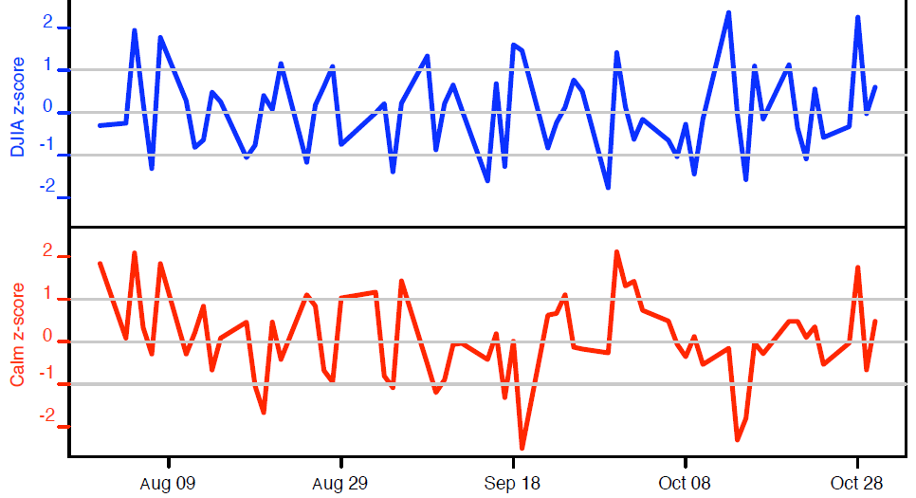

  The test show the up and down of stock market at the prediction accuracy of 86.7%.

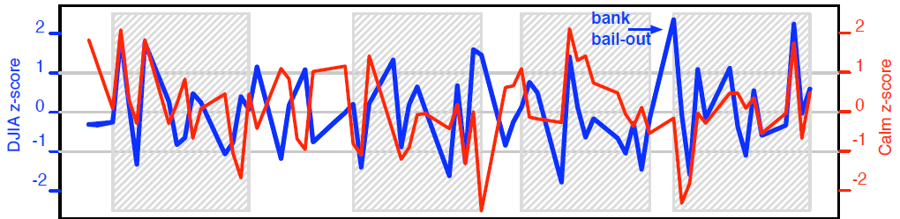

Using OpinionFinder and Google-Profile of Mood States, they predict mood for stock market investment.

OpinionFinder is an open source tool measuring the opinions in twitter, which are positive or negative. It is combined with the psychological tool, Profile of Mood State, which combines 72 emotional status words with GPOMS, producing 6 mood words: Calm, Alert, Sure, Vital, Kind, and Happy.

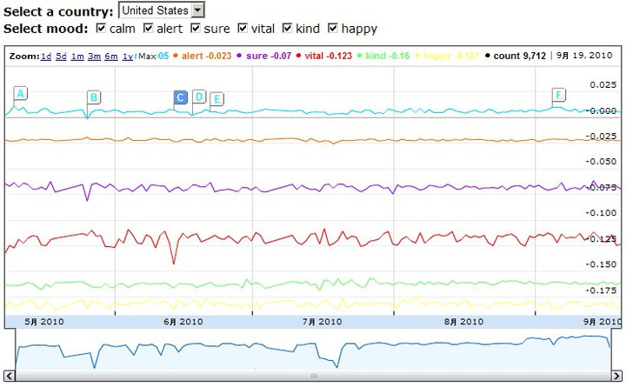

12 combinations, positive/negative x 6 mood, are used to analyze 2700,000 twitter’s 9800,000 twitts between Feb. 2008 to Dec. 2008.

 The data may be found in <http://terramood.soic.indiana.edu/annotated_line.php>

Above graph shows status of mind in year 2010.